COVID-19 Workspace Safety Plan
Use of this template: All light italicized grey font are instructional and must be removed before final copy is approved. Management of the workspace must review and approve of this plan. Any modification of the requirements outlined in this template must contact UBC Safety & Risk Services for approval.

This plan requires the review of the operational activities in your workspace to ensure effective controls are in place to prevent the transmission of COVID-19. Management and supervisory staff are responsible for developing and updating this document to meet current government mandated requirements. https://covid19.ubc.ca/

Department / Faculty | UBC Library / VP Academic
Facility Location | Rare Books and Special Collections, IKBLC, 1961 East Mall
Proposed Re-opening Date | November 1, 2020
Workspace Location | Irving K. Barber Learning Centre, Room 110

Introduction to Your Operation
1. Scope and Rationale for Opening
RBSC archival and donation processing is proposed in order to process three significant incoming donations to complete donor-required applications for the Department of Canadian Heritage Canadian Cultural Property Export Review Board (CPERB) designation, due on January 6, 2021. Only two staff—RBSC’s Natural Resources Archivist and the RBSC librarian—will be onsite in order to facilitate the donation processing.

RBSC’s Natural Resources Archivist will need to be onsite in order to process the archival portions of the donations for appraisal by the CPERB appraisal board. This work cannot be done remotely. In compliance with RBSC’s internal security policy, a second staff member will need to be onsite. During this time, the RBSC Librarian will work to inventory and assess the book portions of the donations, as well as access physical collections in order to support faculty needs for remote learning and instruction in the fall term. In addition, the RBSC Librarian will also be able to respond to faculty and student reproduction requests, which are currently going unfulfilled.

There will be no public access at this time to RBSC collections. Other RBSC staff may need occasional access to the space, and access will be requested per the facilities service request form process that is currently in place. Should additional RBSC staff be approved for access to the space, appropriate adjustments will be made to ensure that the number of staff in the space is limited to two people.

The following risks are considered in accordance with https://srs.ubc.ca/covid-19/safety-planning/determining-safety-plan-risk/
- Risk #3 – The workplace or activity is indoors and windows cannot be opened
RBSC is located in the basement of the Irving K. Barber Learning Centre, and no windows are available to open. All workplace activities take place indoors.

This plan has been vetted by RBSC unit head, Katherine Kalsbeek. As well, this plan has been reviewed by the Teal Zone Facilities Manager, the Director of Custodial Services, our SRS Contact, and UBC Library JOHSC.

Section #1 – Regulatory Context
2. Federal Guidance
- Government of Canada: “Hard-surface disinfectants and hand sanitizers (COVID-19): List of disinfectants with evidence for use against COVID-19”
- The Risk mitigation tool for workplaces/businesses operating during the COVID-19 pandemic
3. Provincial and Sector-Specific Guidance
- BC’s Restart Plan: “Next Steps to move BC through the pandemic”
- BC COVID-19 Self Assessment Tool
- BC COVID-19 Go-Forward Management Strategy
- BC Centre for Disease Control Prevention and Risks
4. Worksafe BC Guidance
- COVID-19 and returning to safe operation – Phase 2
- Worksafe COVID-19 Safety Plan
- Worksafe: Designing Effective Barriers
- Worksafe: Entry Check for Workers
- Worksafe: Entry Check for Visitors
- WorkSafeBC Protocol: Offices
- WorkSafeBC Protocols: Post-Secondary Education
5. UBC Guidance
- COVID-19 Campus Rules
- Guidelines for Preparing for Reoccupancy
- Guidelines for Safe Washroom Reoccupancy
- Space Analysis and Reoccupancy Planning Tool
- UBC Employee COVID-19 PPE Guidance
- Ordering Critical Personal Protective Equipment
- UBC Employee COVID-19 Use of Shared UBC Vehicles Guidance
- UBC Facilities COVID-19 website - Service Level Information
- UBC Employees COVID-19 Essential In-person Meetings/Trainings Guidance
- Workplace Physical distancing Planning Tool and Signage Kit
- Preventing COVID-19 Infection in the Workplace training course
- UBC Cleaning Standards & Recommendations for Supplementary Cleaning
- UBC Classroom Safety Planning
- UBC Signage
- COVID-19 Safety Plan Addendum: Required Non-Medical Masks

6. Professional/Industry Associations
- Museum of Anthropology COVID-19 Response and Safety Plan
- Reopening Archives, Libraries, and Museums (REALM) Information Hub: A COVID-19 Research Project
- Northeast Document Conservation Center, Disinfecting Books and Other Collections
- BCLA’s Back to the Office Guidelines for Staff and Co-workers
- IFLA - COVID-19 and the Global Library Field - Reopening Libraries

Section #2 - Risk Assessment
As an employer, UBC has been working diligently to follow the guidance of federal and provincial authorities in implementing risk mitigation measures to keep the risk of exposure as low as reasonably achievable. This is most evident in the essential service areas that have remained open on campus to support the institution through these unprecedented times. These areas have been very active with respect to identifying and mitigating risks, and further re-evaluating the controls in place using the following risk assessment process.

Prior to opening or increasing staff levels:
Where your organization belongs to a sector that is permitted to open, but specific guidance as to activities under that sector are lacking, you can use the following risk assessment approach to determine activity level risk by identifying both your organization’s or activity’s contact intensity and contact number, as defined below:

- What is the contact intensity in your setting pre-mitigation – the type of contact (close/distant) and duration of contact (brief/prolonged)?
- What is the number of contacts in your setting – the number of people present in the setting at the same time? As a result of the mass gatherings order, over 50 will fall into the high risk.

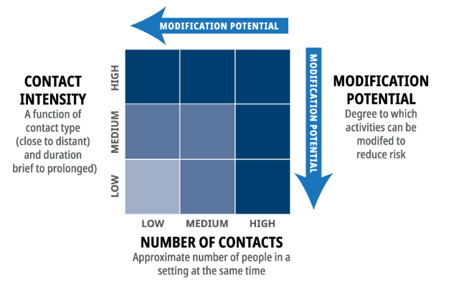

One or more steps under the following controls can be taken to further reduce the risk, including:
- Physical distancing measures – measures to reduce the density of people
- Engineering controls – physical barriers (like Plexiglas or stanchions to delineate space) or increased ventilation
- Administrative controls – clear rules and guidelines
- Personal protective equipment – like the use of respiratory protection

7. Contact Density (proposed COVID-19 Operations)
Describe the type of contact (close/distant) and duration of the contact (brief/prolonged) under COVID operations - where do people congregate; what job tasks require close proximity; what surfaces are touched often; what tools, machinery, and equipment do people come into contact with during work
We propose that only two staff members will be occupying the space. Strict physical distancing and handwashing measures will be in place. The two RBSC staff will be in separate areas of the RBSC office (see keyplan in Appendix A), will have their own workstations (which includes a computer, mouse, keyboard, and phone), and will be working on separate projects with no need to be in close proximity during work tasks.

RBSC staff who will be onsite will be responsible for cleaning and disinfecting their own working stations at end of their shifts using the cleaning solution provided and following safe practices for the Germosolve 5 outlined in the Workplace Hazardous Materials Information (WHMIS) Safety Data Sheet (SDS) (see the yellow SDS link below the Germosolve 5 image). Custodial services will clean high touch surfaces at night.

There are two entrances to the unit (front and rear entrances, per the keyplan in Appendix A), and staff will be able to use separate doors. While working in RBSC, any use of the kitchenette and shared kitchen equipment, will be done in accordance with UBC Library COVID-19 Staff Room Safety Procedures (see Appendix B). Staff working in RBSC will use washrooms designated for their use on level 1 of the IKBLC (rooms 131/132), which are accessible from the RBSC rear / staff entrance. (See keyplan in Appendix A.)

8. Contact Number (proposed COVID-19 Operations)
Describe the number of contacts in your proposed COVID-19 operational setting (# of people present in setting at same time)
Pre-COVID, the general range of normal occupancy for RBSC is 7-14 occupants.

We propose a total of two occupants in RBSC. The RBSC Librarian and Natural Resources Archivist will work onsite at RBSC on Monday-Friday from 9 a.m.-3 p.m. The RBSC Librarian will work in IKBLC room 122 and the Natural Resources Archivist will work in IKBLC room 123 (see keyplan in Appendix A).

9. Employee Input/Involvement
Detail how you have met the MANDATORY requirement to involve frontline workers, Joint Occupational Health and Safety Committees, and Supervisors in identifying risks and protocols as part of this plan
Relevant workers (RBSC Librarian and Natural Resources Archivist) have been involved in the development of this safety plan. The plan has been reviewed by Katherine Kalsbeek, RBSC unit head, and Susan Parker, University Librarian. The UBC Library JOHSC has reviewed and approved this plan.

10. Worker Health
Detail how all Supervisors have been notified on appropriate Workplace Health measures and support available and how they will communicate these to employees
This plan has been reviewed by Katherine Kalsbeek, RBSC unit head, and Susan Parker, University Librarian. All RBSC staff (both those working in-person and remotely) will receive a copy of this plan by email and a copy will be saved on the unit’s shared drive. Details of the plan will also be communicated to staff through RBSC team meetings. Staff will also be directed to https://wellbeing.ubc.ca/wellbeing-campaigns-andinitiatives/
thrive for more information regarding supports available to them.

11. Plan Publication
Describe how you will publish your plan ONLINE and post in HARD COPY at your workplace for employees and for others that may need to attend site
The final copy of RBSC’s Safety Plan will be posted online to the SRS website, the UBC Library COVID-19 Safety Plans page.

All RBSC staff (both those working in-person and remotely) will receive a copy of this plan by email and a copy will be saved on the unit’s shared drive. A hardcopy version will also be posted in the general staff area.

Section #3 – Hazard Elimination or Physical Distancing
Coronavirus is transmitted through contaminated droplets that are spread by coughing or sneezing, or by contact with contaminated hands, surfaces or objects. UBC’s goal is to minimize COVID-19 transmission by following the safety hierarchy of controls in eliminating this risk, as below.

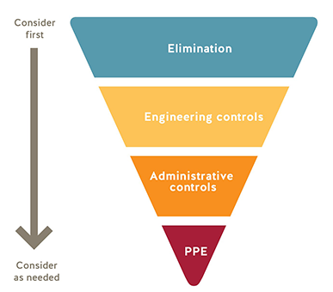

The following general practices shall be applied for all UBC buildings and workspaces:
- Where possible, workers are instructed to work from home.
- Anybody who has travelled internationally, been in contact with a clinically confirmed case of COVID-19 or is experiencing “flu like” symptoms must stay at home.
- All staff are aware that they must maintain a physical distance of at least 2 meters from each other at all times
- Do not touch your eyes/nose/mouth with unwashed hands
- When you sneeze or cough, cover your mouth and nose with a disposable tissue or the crease of your elbow, and then wash your hands
- All staff are aware of proper handwashing and sanitizing procedures for their workspace
- Supervisors and managers must ensure large events/gatherings (> 50 people in a single space) are avoided
- Management must ensure that all workers have access to dedicated onsite supervision at all times.
- All staff wearing non-medical masks are aware of the risks and limitations of the face covering they have chosen to wear or have been provided to protect against the transmission of COVID-19. See SRS website for further information.

12. Work from Home/Remote Work
Detail how/which workers can/will continue to work from home (WFH); this is required where it is feasible
Only the RBSC Librarian and Natural Resources Archivist (Faculty / Librarians) will be working onsite, while other RBSC employees will remain working from home. Pre-COVID, the general range of normal occupancy for RBSC is 7-14 occupants. The two librarians working onsite represent less than 30% of normal occupancy, even at the low end of regular occupancy during pre-COVID operations.

13. Work Schedule Changes/Creation of Work Pods or Crews or Cohorts
For those required/wanting to resume work at UBC, detail how you are able to rescheduling of workers (e.g. shifted start/end times) in order to limit contact intensity; describe how you may group employees semi-permanently to limit exposure, where necessary
The RBSC Librarian and Natural Resources Archivist will work onsite at RBSC on Monday-Friday from 9 a.m.-3 p.m. These hours have been set to allow both team members to travel home safely via bike / on foot as it begins to become dark earlier as the fall term progresses, or alternatively in order to allow them to avoid public transit during peak hours. The RBSC Librarian and Natural Resources Archivist will complete their workdays remotely after returning home.

14. Spatial Analysis: Occupancy limits, floor space, and traffic flows
Describe or use UBC building keyplans (or do both, where appropriate) to identify and list the rooms and maximum occupancy for each workspace/area, explaining your methodology for determining occupancy
Occupancy and distancing: there will only be two employees in the RBSC unit. The Natural Resources Archivist and the RBSC Librarian will be working in separate offices / areas in the unit, which are separated by more than 2 m. The RBSC Librarian will work in IKBLC room 122 and the Natural Resources Archivist will work in IKBLC room 123 (see keyplan in Appendix A.) As per UBC’s COVID-19 Campus Rules, employees will wear a non-medical mask in open office spaces.

Separate entrances into the RBSC unit: Staff will access RBSC by entering IKBLC through the East Mall entrance, accessing the CTLT area on level 2 via card access, and taking the Library staff elevator (one at a time) to the publicly restricted area of level 1. Once there, the two entrances to the RBSC unit (front / public access and rear / staff access) will allow them to enter the unit separately and at a distance. (See keyplan in Appendix A.)

Directional traffic flows: Since there will only be two staff onsite, and they will be working in separate areas, there will not been a need for them to travel along the same path through the office at any time, so one-way traffic flows will not be necessary.

15. Accommodations to maintain 2 metre distance
Please detail what accommodations/changes you have made to ensure employees can successfully follow the rule of distancing at least 2 metres from another employee while working
We propose only two occupants who would be in separate areas of the RBSC office (see keyplan in Appendix A). The two staff members will be working on separate projects, and there will be no need to be in close proximity during work tasks. There are two entrances to the unit, and staff will be able to use separate doors. While working in RBSC, any use of the kitchenette and shared kitchen equipment will be done in accordance with UBC Library COVID-19 Staff Room Safety Procedures. (see Appendix B) Staff working in RBSC will use washrooms designated for their use on level 1 of the IKBLC (rooms 131/132), which are accessible from the RBSC rear / staff entrance (see keyplan in Appendix A). In addition, library staff will adhere to the following protocols when moving through and entering/exiting IKBLC:
- Library staff will follow institutional policies as described in “UBC Employee COVID-19 Physical Distancing Guidance”. A minimum 2-metres (six feet) will be maintained between individuals.
- Library staff will wear a non-medical mask in open office spaces per UBC’s COVID-19 Campus Rules.
- Library staff will follow posted traffic flow decals, including directionality of stairwells, and single occupancy limit of elevators

16. Transportation
Detail how you are able to (or not) apply UBC's COVID-19 vehicle usage guidelines to the proposed operational model - if you cannot apply these guidelines, please describe alternative control measures
Neither of the staff who will be working at RBSC will require the use of a UBC vehicle. We have reviewed the UBC Employees COVID-19 Use of Shared UBC Vehicles guidance document (https://riskmanagement.sites.olt.ubc.ca/files/2020/04/Guidance-for-Shared-Vehicles-FINAL.pdf) and it is not applicable, as we will not be using vehicles.

17. Worker Screening
Describe how you will screen workers: 1) exhibiting symptoms of the common cold, influenza or gastrointestinal; 2) to ensure self-isolation if returning to Canada from international travel; and 3) to ensure self-isolation if clinical or confirmed COVID-19 case in household or as medically advised
As per Provincial Health guidelines, employees must complete a daily health check before entering the workplace by completing the BC COVID-19 Health Check. Anybody experiencing any symptoms of COVID-19 will notify their supervisor and not come to work. Staff in this situation will either work from home or take sick time depending on the situation.

Our screening process will also include front and rear entry door (see keyplan in Appendix A) signage for both workers that prohibits entry if any of the above 3 criteria apply. The following sign will be posted on the front and rear entrances to the unit where staff from RBSC will enter: WorkSafeBC: Entry Check for Workers.

RBSC unit head will be responsible to ensure the staff who are ill do not return to work until they are well and cleared to do so. RBSC staff will use the self-assessment tool provided by the province of BC to evaluate their health status before coming to work: https://bc.thrive.health/covid19/en

18. Prohibited Worker Tracking
Describe how you will track and communicate with workers who meet categories above for worker screenings
- Employees feeling ill, with any common cold, influenza or COVID-19-like symptoms, will be asked to stay home and isolate for 10 days following the onset of symptoms, not returning to work until symptoms resolve
- The direct supervisor and unit head will use the Library’s internal systems to track any workers who cannot attend work due to one or more of the three categories of restriction (as defined by WorkSafe BC).
- Unit Head will report to Associate University Librarian who will report to the University Librarian and the Back to Campus Transition Planning Team. Following this, we will reach out to our Safety and Facilities Officer for further direction.

Section #4 – Engineering Controls
19. Cleaning and Hygiene
Detail your cleaning and hygiene plan, including identification for hand-washing stations and the cleaning regimen required to be completed by your departmental staff (i.e. non-Building Operations) for common areas/surfaces
- RBSC will be included in the general cleaning and hygiene protocols for UBC Library and IKBLC (http://buildingoperations.ubc.ca/2020/05/25/custodial-services-keeping-your-facility-clean-and-sanitized/). Custodial standards will apply, and custodial services will clean designated washrooms within each library and high touch point areas in main corridors, elevators and stairways once per day and once during the evening shift.
- A sink is available in the RBSC office space to facilitate frequent handwashing.
  - Shared workstations, or equipment (photocopiers, phones) must be cleaned before use, using paper towel and provided cleaning solution.
  - Employees will wash their hands before and after cleaning shared and personal equipment.

20. Equipment Removal/Sanitation
Detail your appropriate removal of unnecessary tools/equipment/access to areas and/or adequate sanitation for items that must be shared that may elevate risk of transmission, such as coffee makers, kettles, shared dishes and utensils
RBSC staff will use any shared kitchen equipment in accordance with UBC Library COVID-19 Staff Room Safety Procedures (see Appendix B). Personal workstations will be utilized solely by each individual. Similarly, book-trucks and processing materials will be assigned to each staff member for their use only. Printers, scanners and photocopiers will be cleaned by employees prior to use. Custodial services will clean high touch surfaces at night.

21. Partitions or Plexiglass installation
Describe any inclusion of physical barriers to be used at public-facing or point-of-service areas
N/A. The two staff members who will be onsite will be working in separate areas of the office more than 2-metres apart, so there is no need at this time for partitions or barriers. There will be no interaction with the public or points-of-service.

Section #5 – Administrative Controls
22. Communication Strategy for Employees
Describe how you have or will communicate the risk of exposure to COVID-19 in the workplace to your employee, the conduct expectations for the employee's physical return to work around personal hygiene (including use of non-medical masks), the familiarization to contents of this plan, including how employees may raise concerns and how you will address these, and how you will document all of this information exchange
Only selected workers will be returning to the workplace, following an established schedule. These workers will participate in training related to mitigating risk; supervisors will share and post written procedures and protocols for mitigating risk; when workers need to raise questions, they will raise them to their supervisors or unit heads who will follow-up in order to respond to or escalate them appropriately. RBSC staff will complete the Preventing COVID-19 Infection in the Workplace training to collectively understand the risk of exposure to COVID-19 in the workplace. Supervisor will communicate self screening protocols to workers by email, online or phone. Signage will be posted. RBSC workers will notify supervisors if they are ill and, if ill, they will not come into the workplace. Workers will raise health and safety concerns with Supervisors and Unit Heads via email, online or phone. Unit Heads will follow-up with Associate University Librarians and other relevant groups to resolve any issues.

23. Training Strategy for Employees
Detail how you will mandate, track and confirm that all employees successfully complete the Preventing COVID-19 Infection in the Workplace online training; further detail how you will confirm employee orientation to your specific safety plan
RBSC staff will submit their PDF certificates of completion for the online training ‘Preventing COVID-19 Infection in the Workplace’ to the unit head, and completion certificates will be kept on the RBSC shared drive so that all staff have access to them. A spreadsheet tracking completion of the online training will also be maintained on the shared drive. Existing signage related to screening as outlined in question 25 will be in place at the front and rear entrances (see keyplan in Appendix A) to the unit (WorkSafeBC: Entry check for Workers and Visitors).

The Safety Plan will be shared with staff both through email and will be made available as a shared document. Staff can either provide a signature or email confirmation that they have received, read, and understood the contents of the plan.

24. Signage
Detail the type of signage you will utilize and how it will be placed (e.g. floor decals denoting one-way walkways and doors)
As RBSC will remain closed to the public, existing signage will remain posted at all public entrances explaining the current state of closure. RBSC employees will post the following signs:
- Designated handwashing station
- UBC Library COVID-19 Staff Room Safety Procedures in the kitchenette area
- Cleaning instructions for cleaning workstations/using Germosolve 5
- Signs denoting where two-way walkways are in use and to remind RBSC staff to verbalize presence before entering

In addition, signs provided by UBC and put up by other UBC Library employees will include:
● Entry Checklist to be posted on all Library entrances ● Washroom Occupancy limit (for designated washrooms) ● Please do not use signs for washrooms not in use ● Please do not use this sink for sinks external to washrooms that are not designated handwashing stations ● Elevator limit signage

25. Emergency Procedures
Recognizing limitations on staffing that may affect execution of emergency procedures, detail your strategy to amend your emergency response plan procedures during COVID-19. Also describe your approach to handling potential COVID-19 incidents
In the event of an emergency, employees working on site will go to the established Muster Areas, as indicated in our building-specific BERP. Staff working in the space will report to the Firefighters that the building is cleared. If there is an immediate threat to personal health and safety, workers will contact Campus Security and call 911. Protocols for infection control will be implemented as they are established by the Faculty of Arts. Staff who feel ill will contact UBC First Aid (604-822-4444). Mobile first aid attendants will be dispatched to RBSC. UBC First Aid will assess the employee to determine the best course of action. This might include sending the employee home or arranging for further medical attention. Staff who exhibit any symptoms of COVID-19 will leave campus immediately.

26. Monitoring/Updating COVID-19 Safety Plan
Describe how monitor your workplace and update your plans as needed; detail how employees can raise safety concerns (e.g. via the JOHSC or Supervisor) - plan must remain valid and updated for next 12-18 months
The two staff who will be returning to work in office will communicate about the Workspace Safety Plan during weekly meetings with their supervisor, as well as whenever necessary via phone and/or e-mail. If either employee demonstrates signs and symptoms of COVID-19 the plan will also be immediately reviewed and updated. As the plan is updated, the version on the website and any posted hard copies will be updated. All library staff will receive a copy of the new plan either electronically or in hard copy. Any concerns raised by employees will be brought to the attention of the Back to Campus Transition Planning Team by their supervisor.

27. Addressing Risks from Previous Closure
Describe how you will address the following since the closure: staff changes/turnover; worker roles change; any new necessary training (e.g. new protocols); and training on new equipment
We do not anticipate any new staff changes or turn-over. The returning staff are not new to the organization and their roles will not change. They will be conducting the same work and using existing procedures/workflows and equipment that will be adapted for safety in the COVID-19 environment. All employees on site will be required to complete UBC’s COVID-19 Safety Training online module. Training on new protocols will be done via virtual meetings. In case a face-to-face meeting is absolutely necessary, RBSC staff will strictly adhere to physical distancing requirements and all LSC space-use restriction (https://riskmanagement.sites.olt.ubc.ca/files/2020/04/Guidelines-for-Meetings-Trainings-FINAL.pdf)

Section #6 – Personal Protective Equipment (PPE)
28. Personal Protective Equipment
Describe what appropriate PPE you will utilize and how you will/continue to procure the PPE
PPE is not required because physical distance will be in place at all times. In compliance with UBC’s COVID-19 Safety Plan Addendum: Required Non-Medical Masks, RBSC staff will wear non-medical masks in all of the unit’s common indoor spaces include hallways, stairways, building entryways, washrooms, and other high-traffic areas.

Section #7 – Non-Medical Masks

29. Non-Medical Masks
Describe your plan to inform faculty and staff on the wearing of non-medical masks
- All staff in RBSC will follow the requirements around mask-wearing described in https://srs.ubc.ca/covid-19/health-safety-covid-19/non-medical-masks/ and https://srs.ubc.ca/files/2020/06/4.-COVID-19-Campus-Rules.pdf.
  - RBSC staff has consulted the COVID-19 Safety Plan Addendum: Required Non-Medical Masks document (Appendix C) as a guidance tool on how to incorporate NMMs into the plans and the workplace.
  - Effective September 16, 2020 UBC implemented a policy whereby students, faculty, staff and visitors are required to wear non-medical masks in common indoor spaces on campus.
  - Office Spaces:
  - Non-medical masks are not required when working in a sole occupant office or enclosed room. Non-medical masks are required in personal work cubicle
  - Lunch or Breakrooms
Effective September 16, 2020, UBC implemented a policy whereby students, faculty, staff and visitors are required to wear non-medical masks in common indoor spaces on campus.

Section #8 - Acknowledgement
29. Acknowledgement
Plan must demonstrate approval by Administrative Head of Unit, confirming: 1) the Safety Plan will be shared with staff and how; 2) staff will acknowledged receipt and will comply with the Safety Plan.
The Safety Plan will be shared with staff both through email and will be made available as a shared document. Staff can either provide a signature or email confirmation that they have received, read, and understood the contents of the plan. Staff will use the template below to confirm and track their receipt and understanding of the safety plan.

I acknowledge that this Safety Plan has been shared with staff both through email and will be made available as a shared document. Staff can either provide a signature or email confirmation that they have received, read and understood the contents of the plan.

Date
Name (Manager or Supervisor)
Title

Faculty and Staff Occupying Workspace
Name | Email | Confirmation of Understanding
Chelsea Shriver | chelsea.shriver@ubc.ca | X
Claire Williams | claire.williams@ubc.ca | X
 |  | ☐

Appendix A
Please attach any maps, pictures, departmental policies or risk assessments applicable UBC Guidance documents, where necessary, and other regulatory requirements referred to in document.

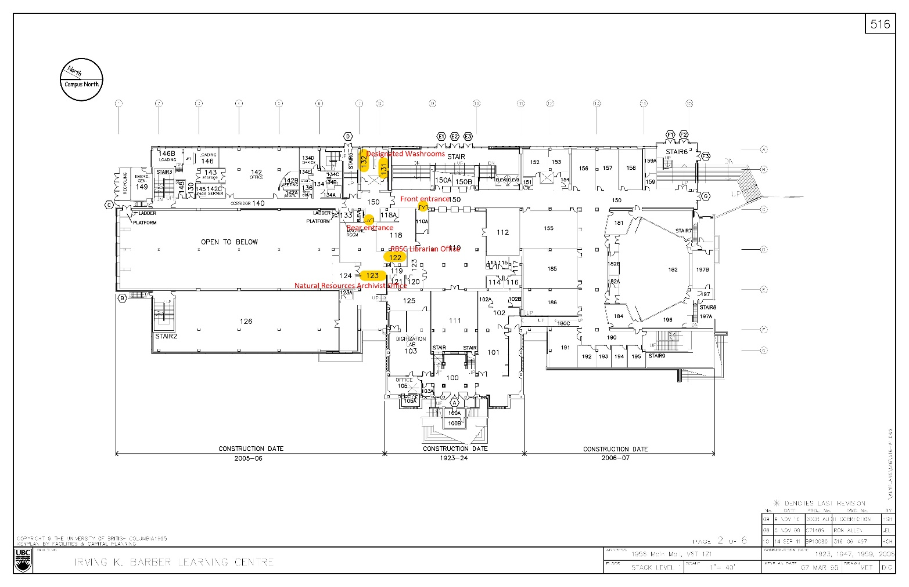

Appendix B

UBC Library COVID-19 Staff Room Safety Procedures

Employee Safety Protocols

- As per UBC’s COVID-19 Campus Rules, employees will wear a non-medical mask inside staff rooms. Proper use of masks is outlined (Appendix A)
- Signage is posted reminding staff to practice proper physical distancing (Appendix B)
- Signage is posted reminding staff to practice proper hand hygiene (Appendix C)
- Signage indicating the maximum staff room occupancy is posted on the door of the staff room and within the staff room
- Furnishings will be moved or removed to ensure 2 metres distance if staff are using the space
- Ensure appropriate cleaning supplies are in stock (Germosolve 5 disinfecting cleaner and hand sanitizer). Contact your direct supervisor if supplies are running low
- Appliances such as fridge, microwave, and kettle must be wiped down between each use with Germosolve 5
- Countertops must be wiped down before and after each use with Germosolve 5
- In low traffic buildings (i.e. all libraries other than IKBLC), tap water should be run for 2 minutes before drinking. No use of water coolers until further notice.
- Please use your own mugs, plates, cutlery, etc. and store in your workspace between use

Staff Occupancy
Occupancy limit of each staff room is based on strict physical distancing guidelines and will vary for each UBC Library branch.

Safety Procedures

Frequently touched surfaces are most likely to be contaminated and increase the transmission of COVID-19. For your and everyone’s safety, please ensure to follow the procedures outlined below.

Use of Staff Room Fridge:
- Wash your hands with warm water and soap for at least 20 seconds
- Use paper towel to turn off water tap and dispose of paper towel immediately (do not place on kitchen counter)
- Spray Germosolve 5 on paper towel (not directly on surface) and wipe down the outside of your food container. Dispose of paper towel immediately
- Spray Germosolve 5 on paper towel (not directly on surface) and wipe down fridge handle. Dispose of paper towel immediately
- Place your container inside the fridge
- Spray Germosolve 5 on paper towel (not directly on surface) and wipe down fridge handle. Dispose of paper towel immediately
- Wash your hands with warm water and soap for at least 20 seconds
- Use paper towel to turn off water tap and dispose of paper towel immediately (do not place on kitchen counter)

Use of Staff Room Microwave:
- Wash your hands with warm water and soap for at least 20 seconds
- Use paper towel to turn off water tap and dispose of paper towel immediately (do not place on kitchen counter)
- Spray Germosolve 5 on paper towel (not directly on surface) and wipe down microwave handle and key pad/buttons
- Place food container in microwave and heat
- Once you have safely removed your food container and set it aside, wipe off any food access/splatters inside the microwave
- Spray Germosolve 5 on paper towel (not directly on surface) and wipe down microwave handle and key pad. Dispose of paper towel immediately
- Wash your hands with warm water and soap for at least 20 seconds
- Use paper towel to turn off water tap and dispose of paper towel immediately

Use of Staff Room Kettle:
- Wash your hands with warm water and soap for at least 20 seconds
- Use paper towel to turn off water tap and dispose of paper towel immediately (do not place on kitchen counter)
- Spray Germosolve 5 on paper towel (not directly on surface) and wipe down kettle handle. Dispose of paper towel immediately
- When pouring boiling water in your cup, ensure that the kettle spout is not in direct contact with your cup. Keep at least a distance of 4 inches above your cup/mug and the kettle spout
- Spray Germosolve 5 on paper towel (not directly on surface) and wipe down kettle handle. Dispose of paper towel immediately
- Wash your hands with warm water and soap for at least 20 seconds
- Use paper towel to turn off water tap and dispose of paper towel immediately (do not place on kitchen counter)

Use of staff room kitchen countertop for basic food preparation:
- Wash your hands with warm water and soap for at least 20 seconds
- Use paper towel to turn off water tap and dispose of paper towel immediately (do not place on kitchen counter)
- Spray Germosolve 5 on countertops and wipe down with paper towel. Dispose of paper towel immediately
- Prepare your food and set aside
- Spray Germosolve 5 on countertops and wipe down with paper towel. Dispose of paper towel immediately
- Wash your hands with warm water and soap for at least 20 seconds

- Use paper towel to turn off water tap and dispose of paper towel immediately (do not place on kitchen counter)

Use of Staff Room Sink:
1. Dishes, cups/mugs, and cutlery should not be left in the sink and must be washed immediately after each use

Appendix C

COVID-19 Workspace Safety Plan Document Revision

Date | Version | Writer | Change Description | Approved By
2020.11.24 | 2.1 | Claire Williams, Natural Resources Archivist; Chelsea Shriver, Rare Books and Special Collections Librarian | Made minor clerical edits to hyperlinks, revised to include new risk levels explanation, revised to include creation of UBC Library COVID-19 Staff Safety Room Procedures, removed mention of UA personnel from plan, revised to reflect UBC’s COVID-19 campus rules, Added Section #7 Non Medical Masks, and included Appendix C : COVID-19 Safety Plan Addendum: Required Non-Medical Masks | Head of Unit / Dean / VP,  Role
2020.12.7 | 2.1 | Katherine Kalsbeek | Updated question 29 and removed Appendix C to reflect guidance provided at https://srs.ubc.ca/covid-19/health-safety-covid-19/non-medical-masks/?login

